SENATOR DAVE DONLEY'S
STATE BUDGET SPEECH
ALLIANCE
DECEMBER 13, 2001

(December 12, 2001 version)

(SLIDE 1)
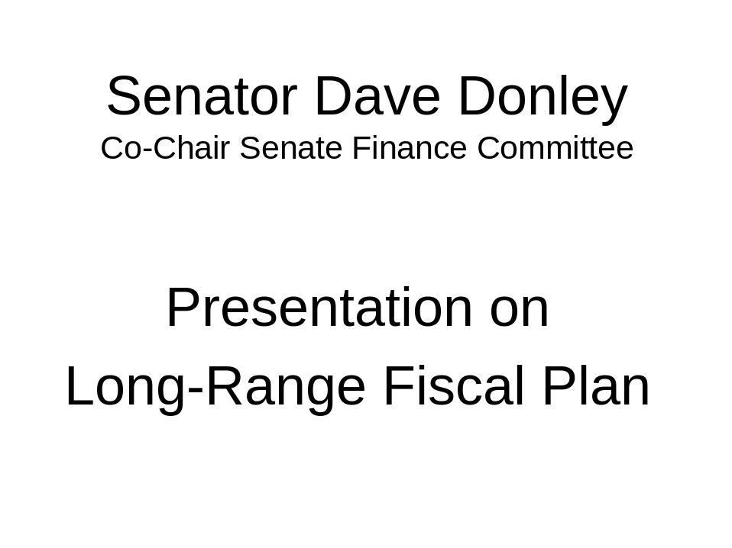

Most Alaskans agree that development of a long-range fiscal plan is one of the greatest challenges facing our state.

(SLIDE 2)
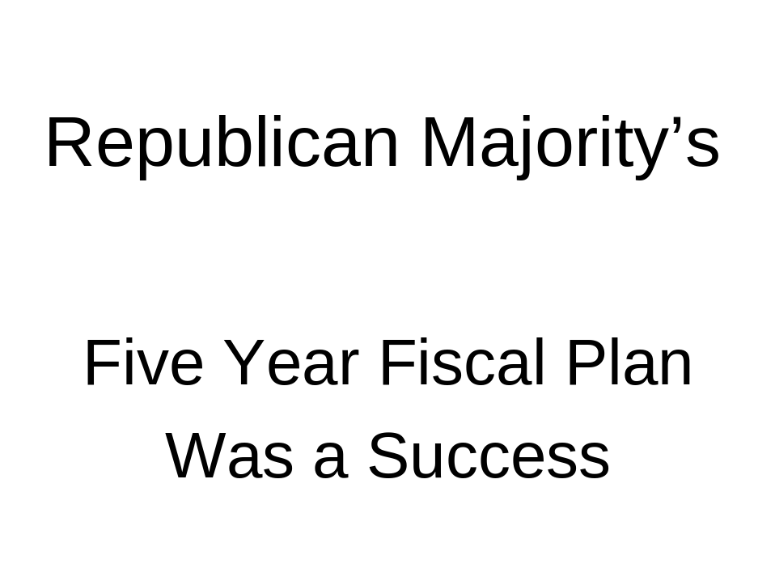
As we begin work on a new plan it is important to recognize that the Republican Majority’s five-year plan, which we completed last year, has built an excellent foundation for Alaska’s long term financial health.

(SLIDE 3)
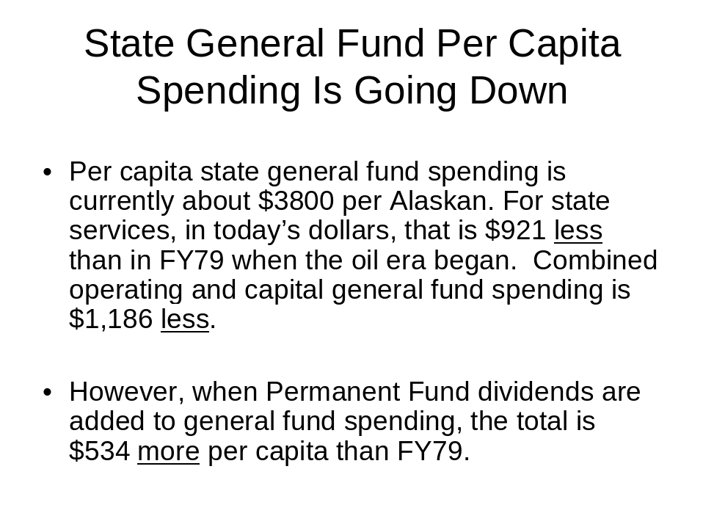
In dealing with the fiscal gap, the key is general fund spending versus revenue. Today real per capita spending of state general funds is significantly less than 1979.

(SLIDE 4)
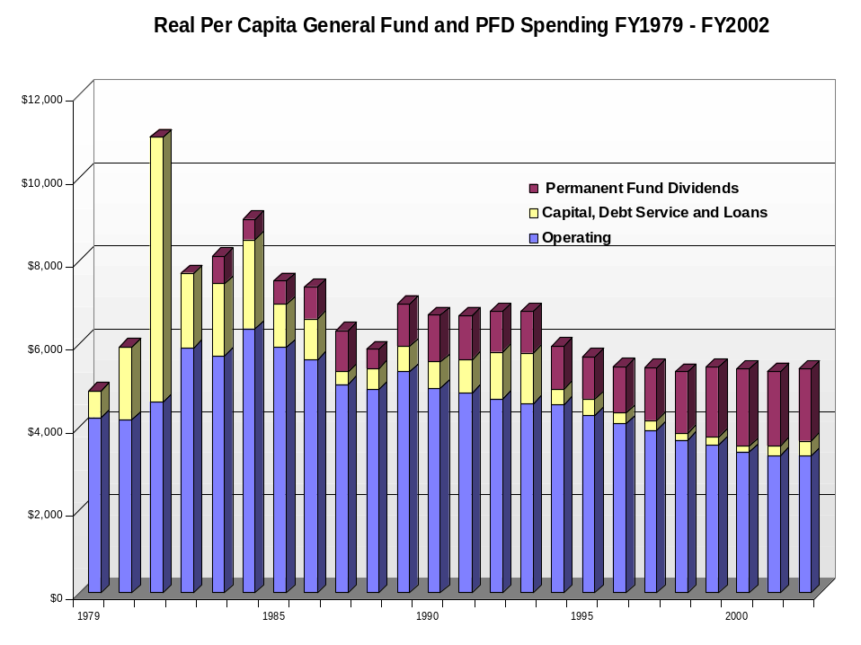
Under that plan the permanent fund was protected and increased by $5 billion to over $25 billion in June, 2001. It is currently $23.5 billion. 61% of that increase was by discretionary legislative action.

(SLIDE 5)
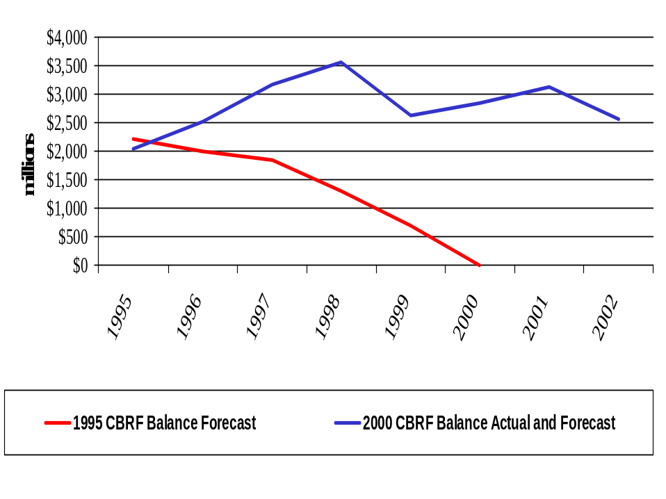
A very surprising fact to most Alaskans is that over the past five years, the constitutional budget reserve, including the PCE endowment, actually increased to over $3 billion in June.

(SLIDE 6)
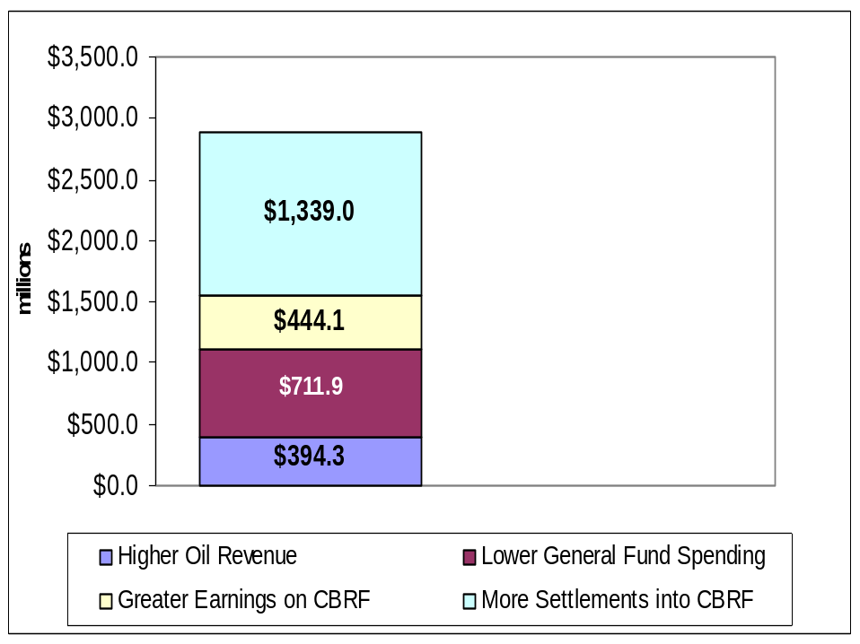(SLIDE 7)
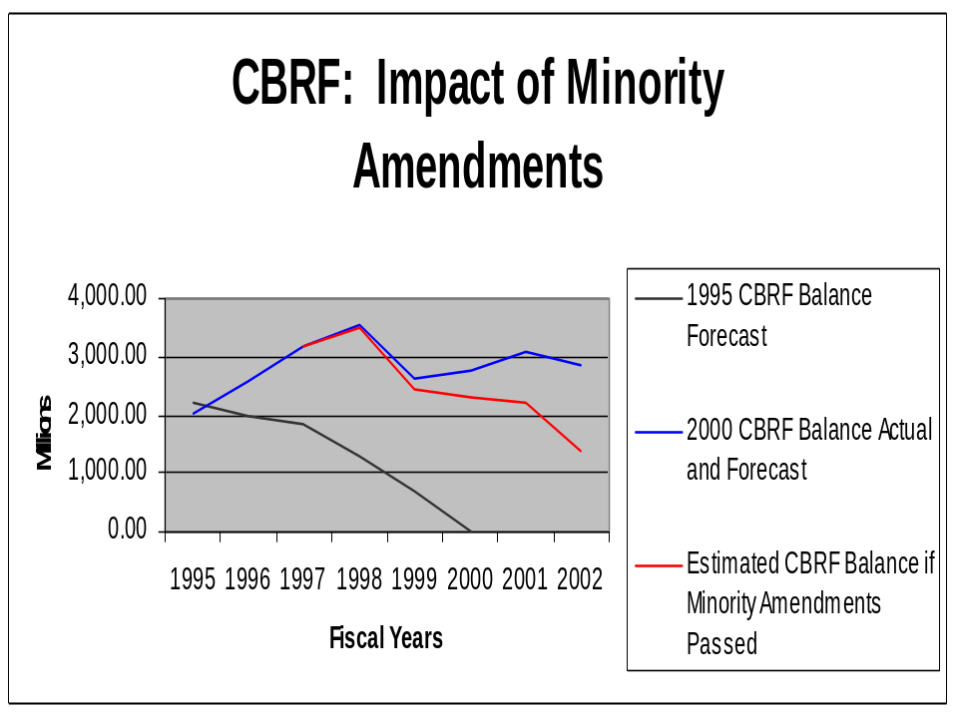

We held the line against more than $800 million of Governor Knowles’ proposed spending increases and actually reduced general fund spending.
We implemented successful major government reforms including:
- Education funding reform
- Welfare reform
- We reduced state bureaucracy and merged state departments
- Reformed power cost equalization
- Underground storage tank funding reform
- Relieved corrections overcrowding
- Increased funding for the University of Alaska and vocational training

We also initiated results-based budgeting, and we increased non-oil revenue.

(SLIDE 8)
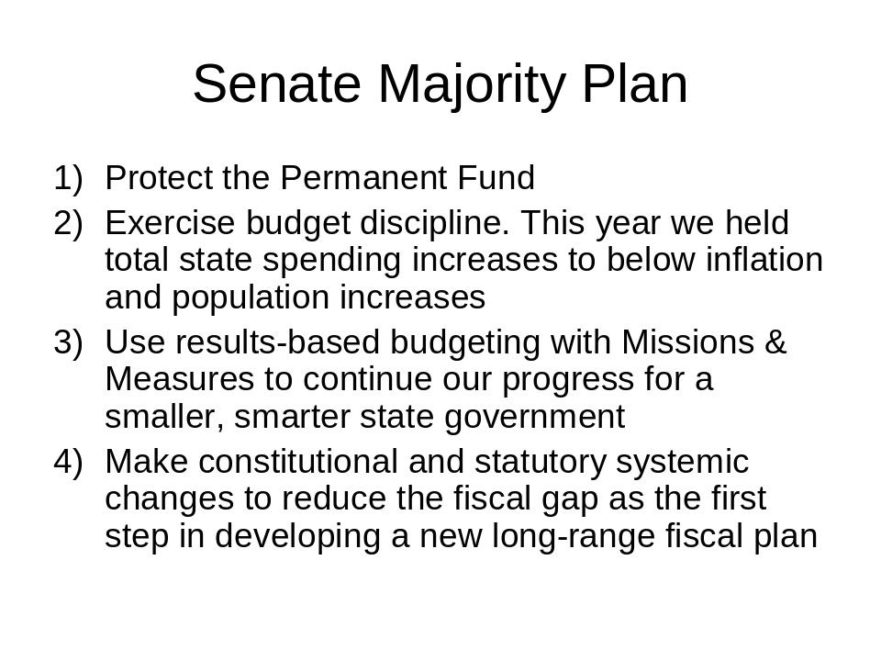
As we build on this tremendous progress and work toward a public statewide consensus on where we, as Alaskans, go from here the Senate Majority intends to continue to:
- Protect the permanent fund.
- Exercise budget discipline.
- Use results-based budgeting with missions & measures to continue our progress for a smarter, smaller state government.
- Make constitutional and statutory systemic changes to reduce the fiscal gap as the first step in developing a new long-range fiscal plan.

After five years of actual reductions in general fund spending, this years’ budget increased general fund spending. But it is still almost $60 million below the governor’s requests and $7 million below last year’s levels when adjusted for population and inflation.

If not for a major decrease in one-time funds, increased medicare/medicaid costs, and major increases to K-12 education, the University of Alaska and public safety, general fund spending would have gone down again this year.

Additional state revenue will be a needed element in a new long-range fiscal plan, but the first step in such a plan should be continued government reforms to create a more efficient and fairer state government. Only after such needed reforms should Alaskans be asked to consider any major new taxes.

(SLIDE 9)
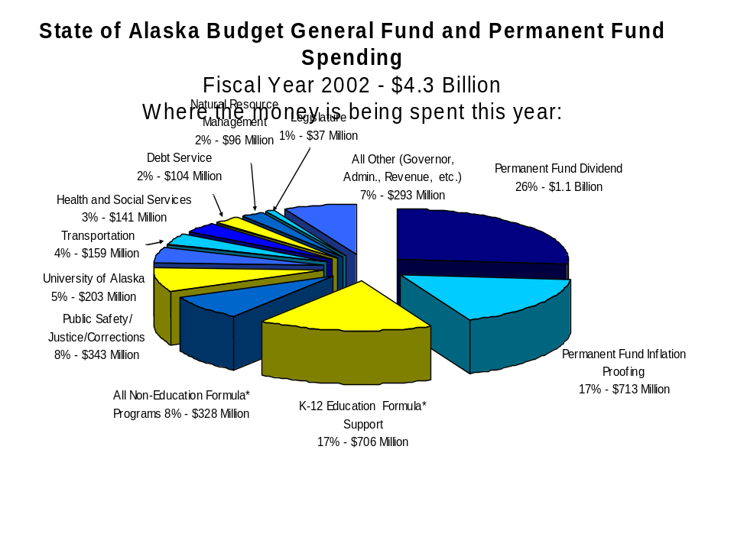
The Senate Republicans believe that before considering major new taxes on Alaskans, government should first be as well run as possible.

To help develop proposals to continue our successful efforts toward a small, smarter state government, earlier this year I wrote the commissioner of every state department and asked if they had any idea for legislation to help improve state government efficiency and reduce the state’s fiscal gap.

Not one made a single suggestion or request for such legislation. I repeat, Governor Knowles’ commissioners did not have a single suggestion for new statutory changes to help reduce the fiscal gap.

(SLIDE 10)
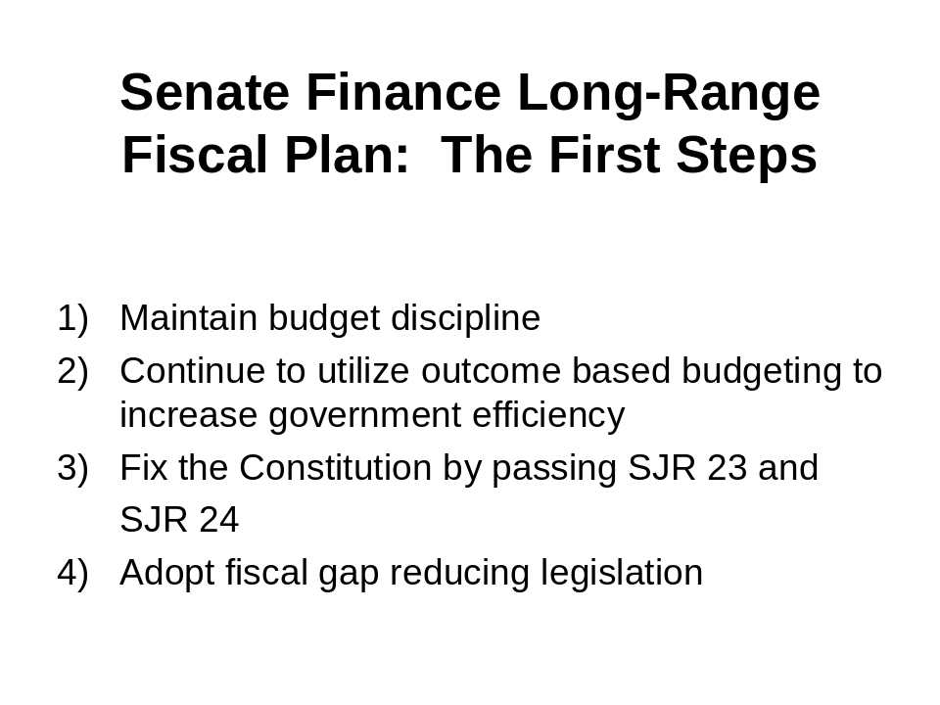
Even so, the Senate Finance Committee developed a package of fiscal reform legislation that continues the Republican Majority’s commitment to fiscal responsibility and government reform before new taxes.

This package presents the first step of a new long-range fiscal plan that has the potential of reducing the fiscal gap by over $12 ½ million a year at first with reductions increasing to over $100 million a year within 10 years. That is a very conservative estimate not including the cumulative impact of these savings.

We do not contend that this is a comprehensive long-range fiscal plan, but we do say it has the essential first ingredients that any new long-range fiscal plan must have to be successful.

The basis of government in America is our constitutions. When we start to create a new financial plan we need to look and make sure that our constitution is functioning properly.

It’s clear that there are two parts of our state constitution that deal with fiscal policy that are not functioning properly. They are the existing constitutional appropriation limit and the existing constitutional budget reserve provision.

(SLIDE 11)
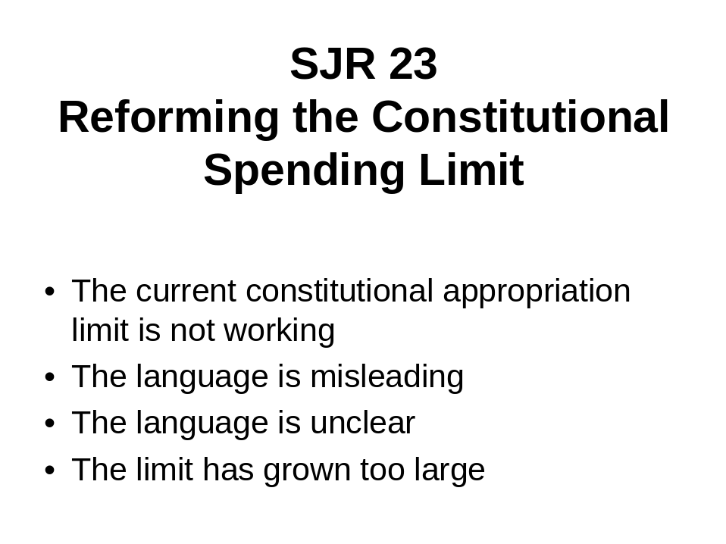
One thing was clear from the overwhelming rejection in September 1999 of the last fiscal plan proposal. . .
Alaskans do not want to give government a blank check.

As that plan left the Senate, it included a constitutional spending limit and specific budget reductions. The House, working with the governor and the Democratic Minority, removed those important fiscal restraints. That was one of the main reasons I strongly opposed the September 1999 proposal – because it lacked clear, enforceable fiscal restraints.

Public opinion polling tells us that to be acceptable to the majority of Alaskans, any new plan must start with reasonable limits on government spending.

The first step to the Senate Finance Committee’s fiscal plan is exactly that. . .
To limit the expansion of government spending through the adoption of Senate Joint Resolution 23, revising the existing constitutional appropriation limit.

TALK ABOUT SLIDE 11 (SLIDE 12)
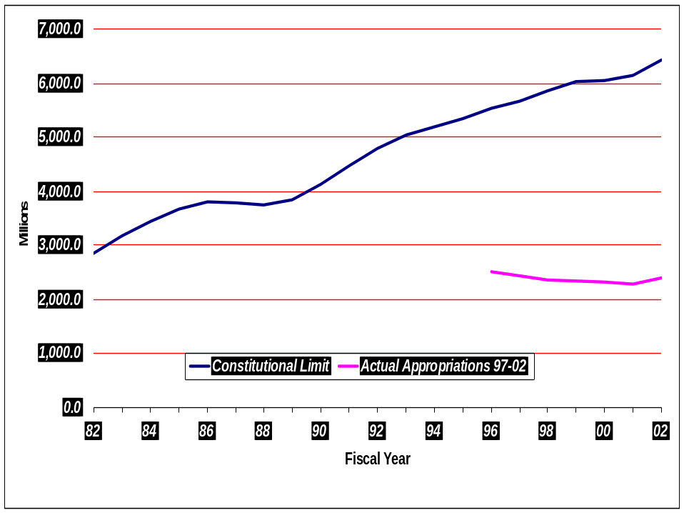
The existing constitutional appropriation limit was adopted by the voters in 1982. This provision currently limits government spending to about $6 billion; however, we only currently spend about $3 billion. The enormous size of the current appropriation limit occurred because the constitutional provision has a built-in escalator clause for inflation and population. To correct this, our most recent version of SJR 23 proposed to base any allowable increases on previous years’ budgets and to limit those increases to only 2 percent. SJR 23 also clarifies what is and is not included in the appropriation limit.

(SLIDE 13)
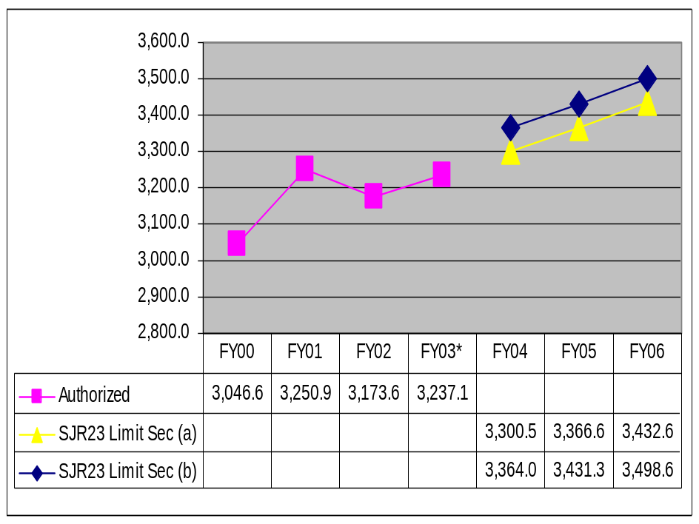
In revising the existing constitutional appropriation limit, we are learning from the mistakes of the past. We recognize, however, that circumstance change. That’s why SJR 23 contains a special provision to have voters review it again in 4 years and then every 6 years thereafter. If it is not functioning correctly, if people want to spend more than the limit allows, or if we solve the fiscal crisis, Alaskans can vote it out of the constitution.

(SLIDE 14)
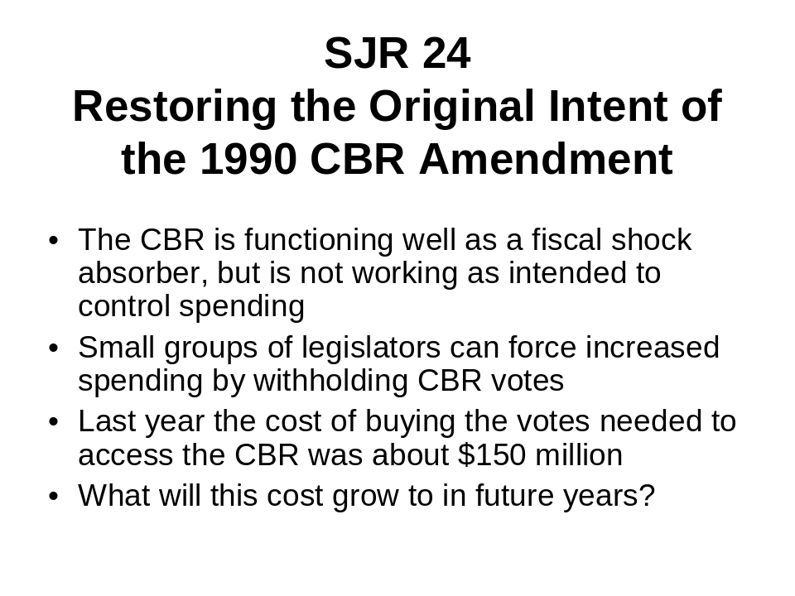
The Constitutional Budget Reserve language of the constitution is working well as a fiscal shock absorber, but it is not working as intended to control spending.

The Constitutional Budget Reserve (CBR) was established in 1990, and has been used to help fill the gap between state revenues and expenditures. When the CBR was created, the original intent was that funds could be withdrawn with a simple majority vote to help cover a budget deficit as long as current spending did not exceed the previous year’s spending, but a three-quarters vote of the legislature would be necessary to withdraw any funds in excess of the previous year’s spending.

In 1994, the Alaska Supreme Court misinterpreted this provision to require a ¾ vote to withdraw any funds from the CBR. This creates a situation in which small groups of legislators can “blackmail” the majority and hold the budget hostage. These legislators can trade their votes, which are crucial to withdraw CBR funds and balance the state’s budget, in exchange for additional spending.

We estimate the cost this year to access the CBR with a ¾ majority vote to balance the budget was nearly $150 million.

Senate Joint Resolution 24 corrects this bizarre imbalance of spending power by proposing a constitutional amendment that makes it clear a ¾ vote is not necessary when spending does not exceed the previous year’s.

If this resolution passes, the amendment will be placed on the next state general election ballot in Fall 2002 for approval by the people of Alaska.

(SLIDE 15)
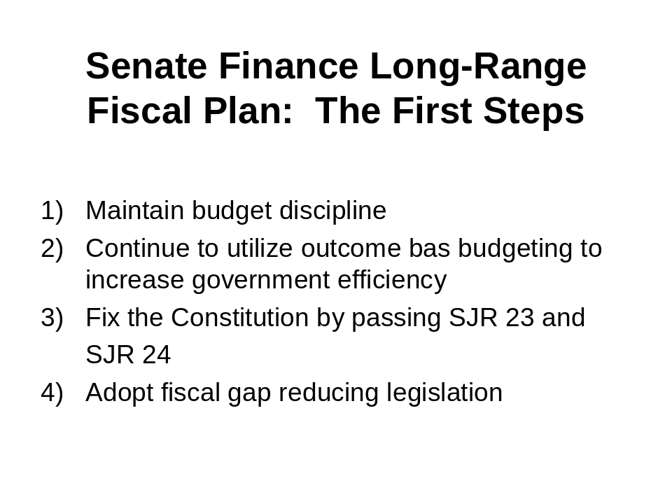
Both these proposed constitutional amendments have already passed the Senate and have begun hearings in the House. Our plan also includes seven other fiscal gap reducing proposals, three of which have already passed the Senate, including SB 186 Limiting Municipal Debt, which I will talk about next.

All together, the savings associated with these reforms grow exponentially in the out years to far exceed their present day value of over $12 million the first year, growing to over $100 million a year within ten years.

Once again, we do not contend that they constitute a complete plan, but these proposals are all in place to pass next year and they are an excellent and necessary first step for any comprehensive new plan to be acceptable to the majority of Alaskans.
SB 186 Power Point Presentation:



